STUDENT HANDOUT HTML-CHAPTER3
HTML TABLES
About Workshop:
In this workshop, We'll cover everything from the basic structure of an HTML table to more advanced topics like adding headers, formatting cells, and incorporating tables into your job portal web application. In this chapter, we are divided into five workshops, each of which illustrates how to effectively utilize these elements in your application. You can also make use of the previously learned tags.
The Scrum Master can divide the workshop among team members, and you can proceed to walk through the tasks assigned to you.
WORKSHOP1:
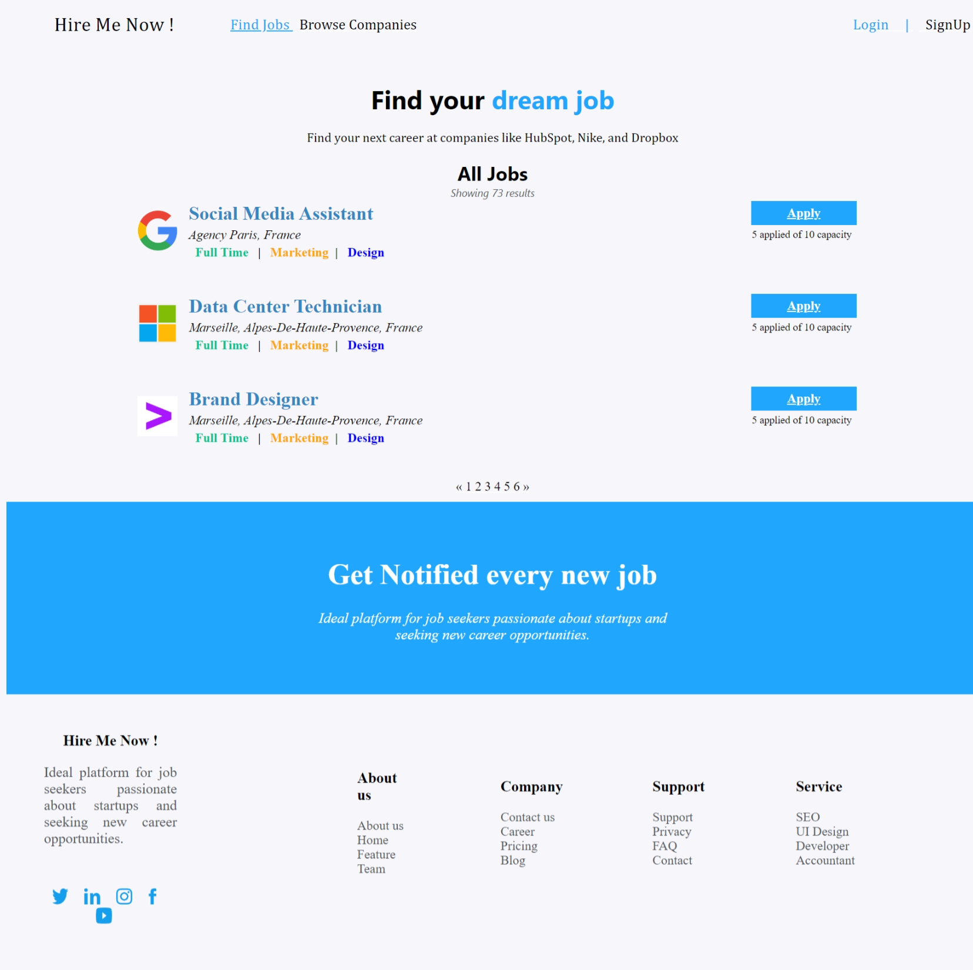

Expected output:-



During this workshop, we will be constructing a homepage for job seekers. On this page, The link, alink, and vlink attributes set the colors for links in various states (normal, active, and visited).The header section includes a table that spans the entire width of the page with some top navigation links. The main content of the page is within another table. Additionally, let's incorporate a footer section as a row in our table, further enhancing the structure and completeness of our tables.

WORKSHOP2:
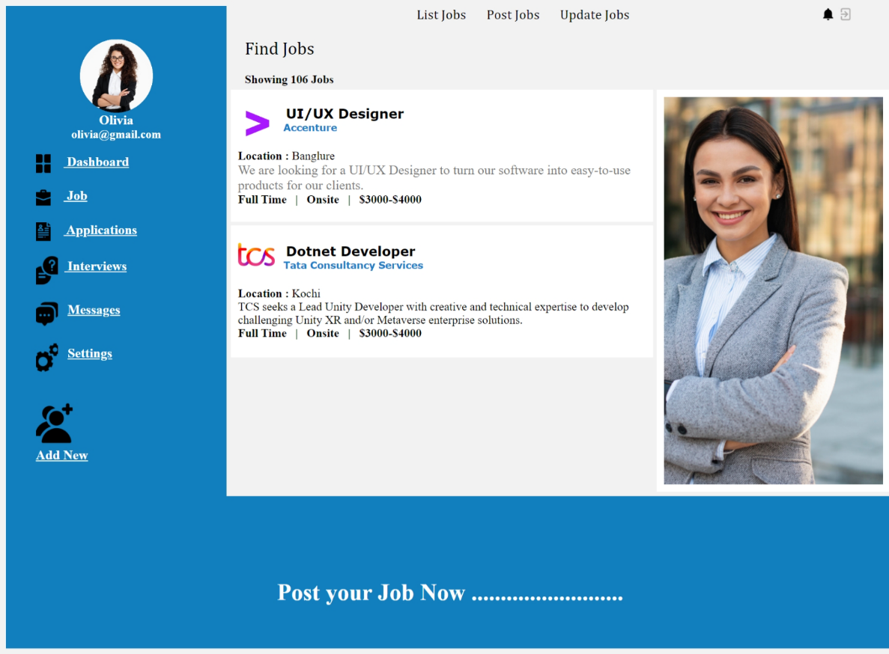

Expected output:-
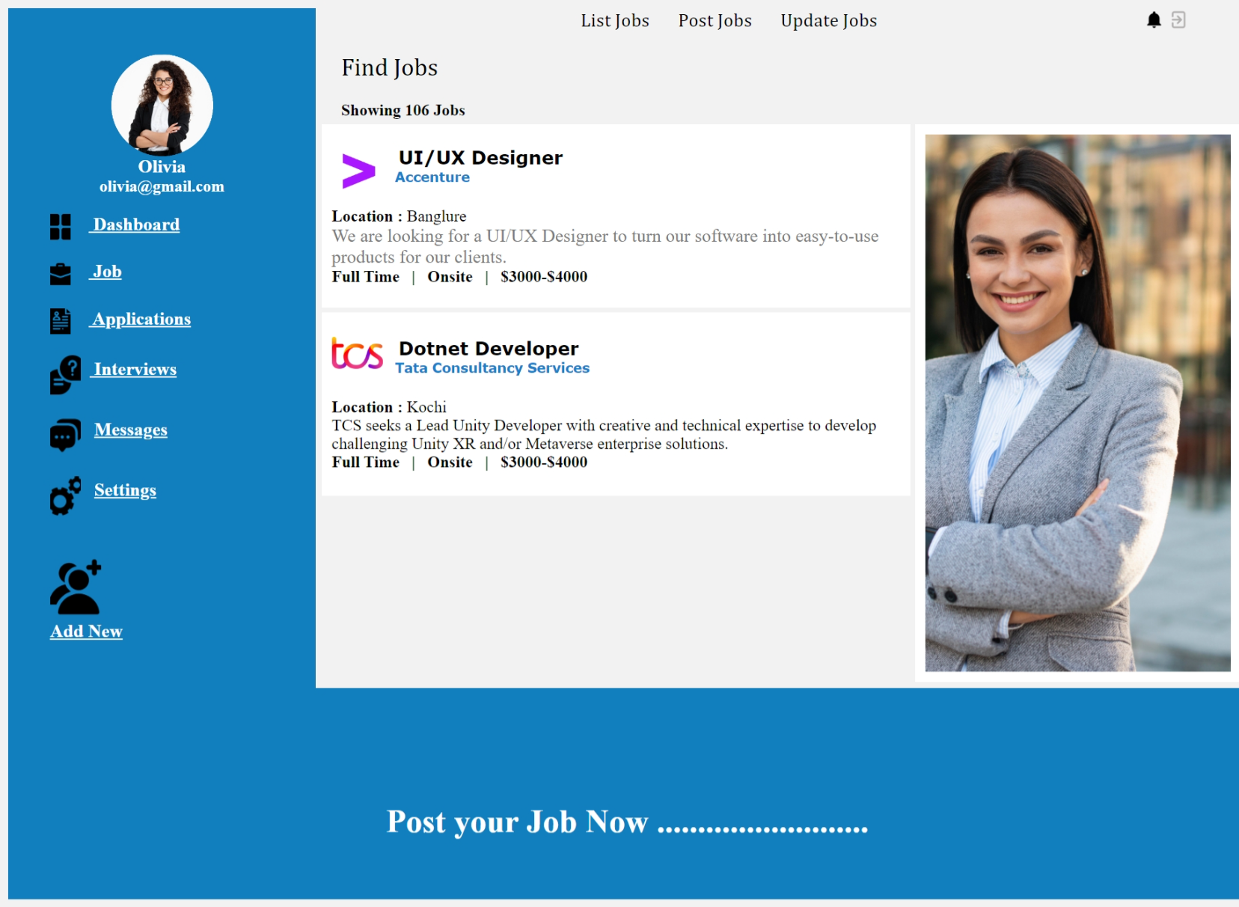
During this workshop, we will be constructing a jobs page for jobProviders. On this page, the link, alink, and vlink attributes set the colors for links in various states (normal, active, and visited).The header section includes a table that spans the entire width of the page with some top navigation links. The main content of the page is within another table. Additionally, let's incorporate a header section as a row in our table, further enhancing the structure and completeness of our tables.
WORKSHOP3:
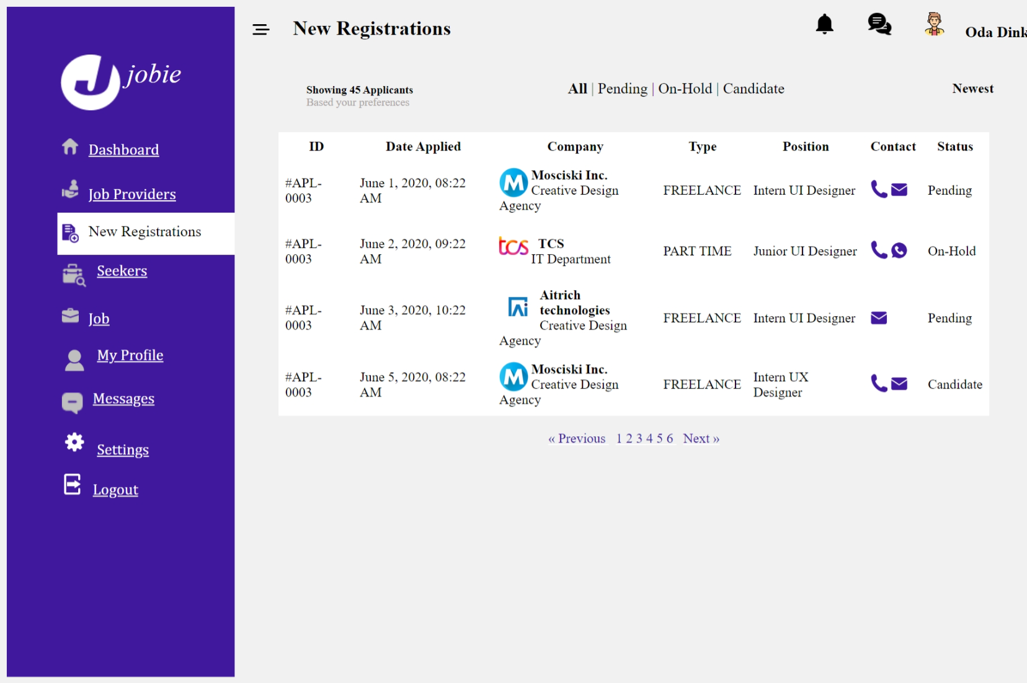

Expected Output:

During this workshop, we will be constructing a homepage for Platform Admin. On this page, using the <table> tag to create a structured layout for a web page, dividing it into rows and columns where content like text and images can be placed. The header section includes a table that spans the entire width of the page with some top navigation links. The main content of the page is within another table. Additionally, let's incorporate a header section as two rows in our table, further enhancing the structure and completeness of our tables.

WORKSHOP4:
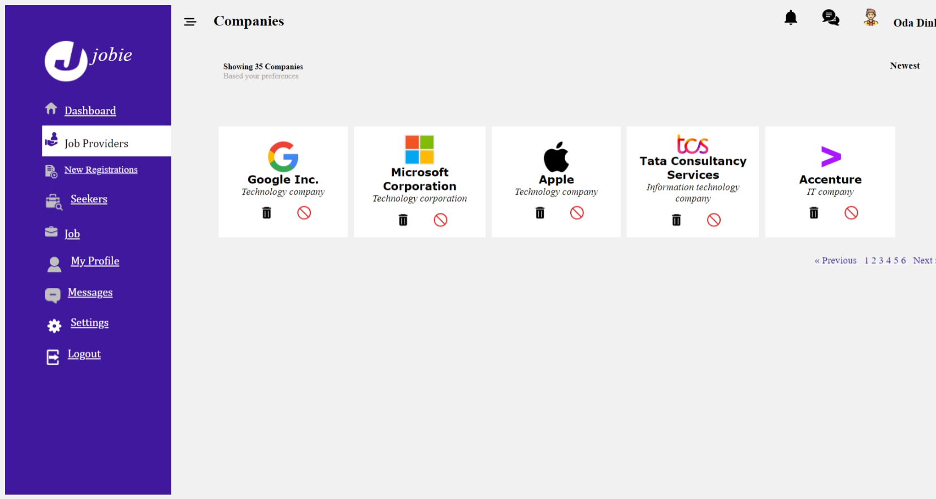
Expected Output: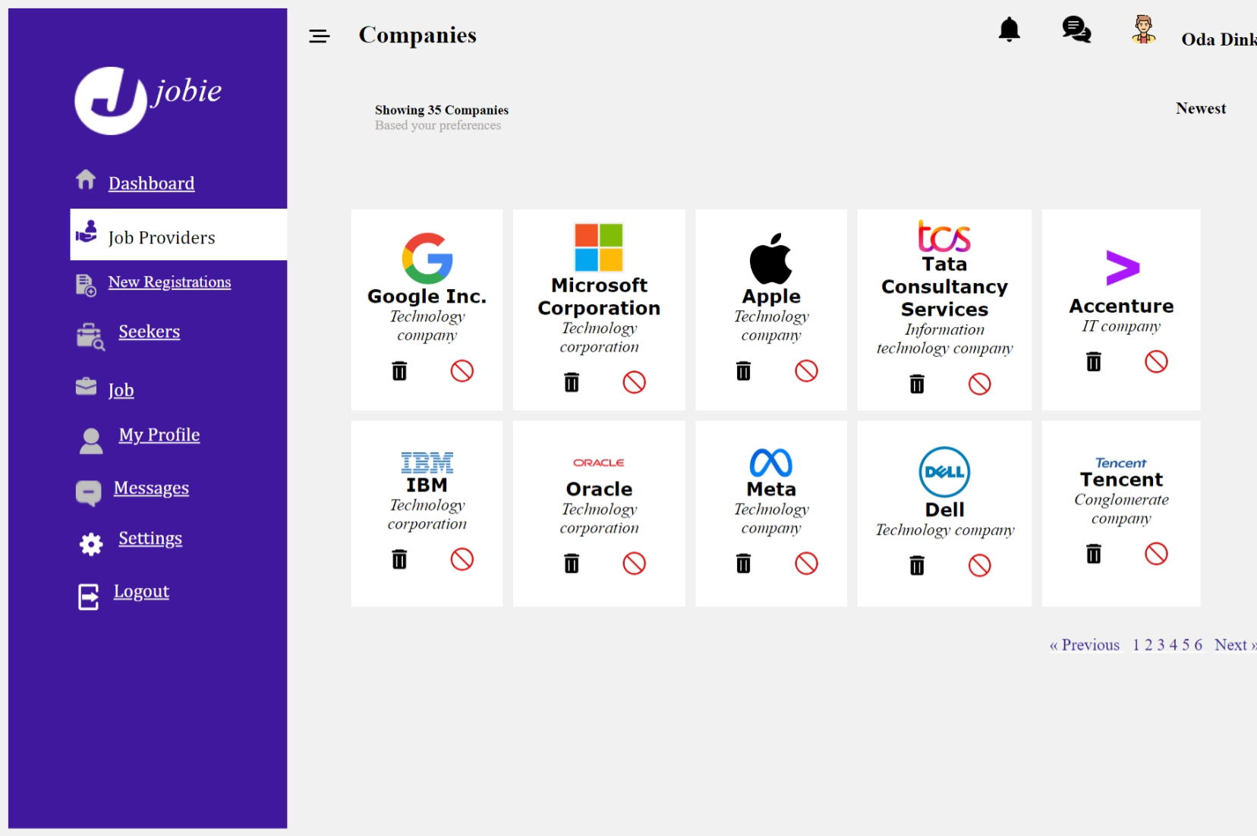

During this workshop, we will be constructing a JobProviders page for Platform Admin. On this page, using the <table> tag to create a structured layout for a web page , dividing it into rows and columns where content like text and images can be placed. The attributes(width,cellpadding,cellspacing,bgcolor,colspan,rowspan) and tags (<table>,<tr>,<td>,<th>)within the table are used to control the appearance and arrangement of this content on the page. , let's incorporate a content section as two rows in our table, further enhancing the structure and completeness of our tables.

WORKSHOP5:
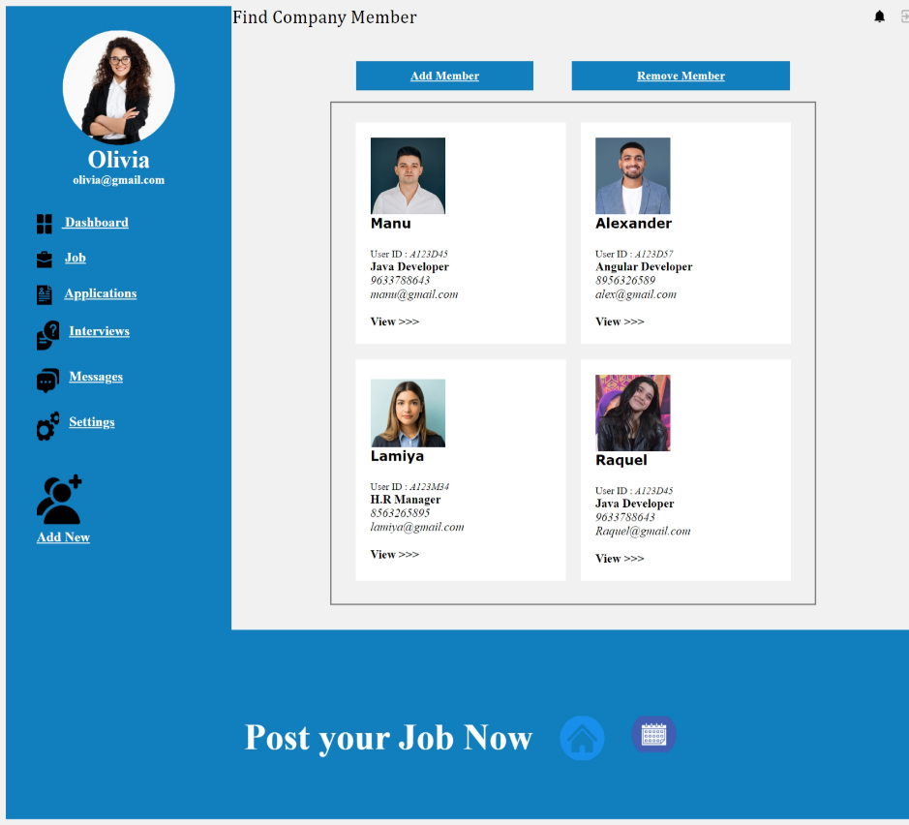
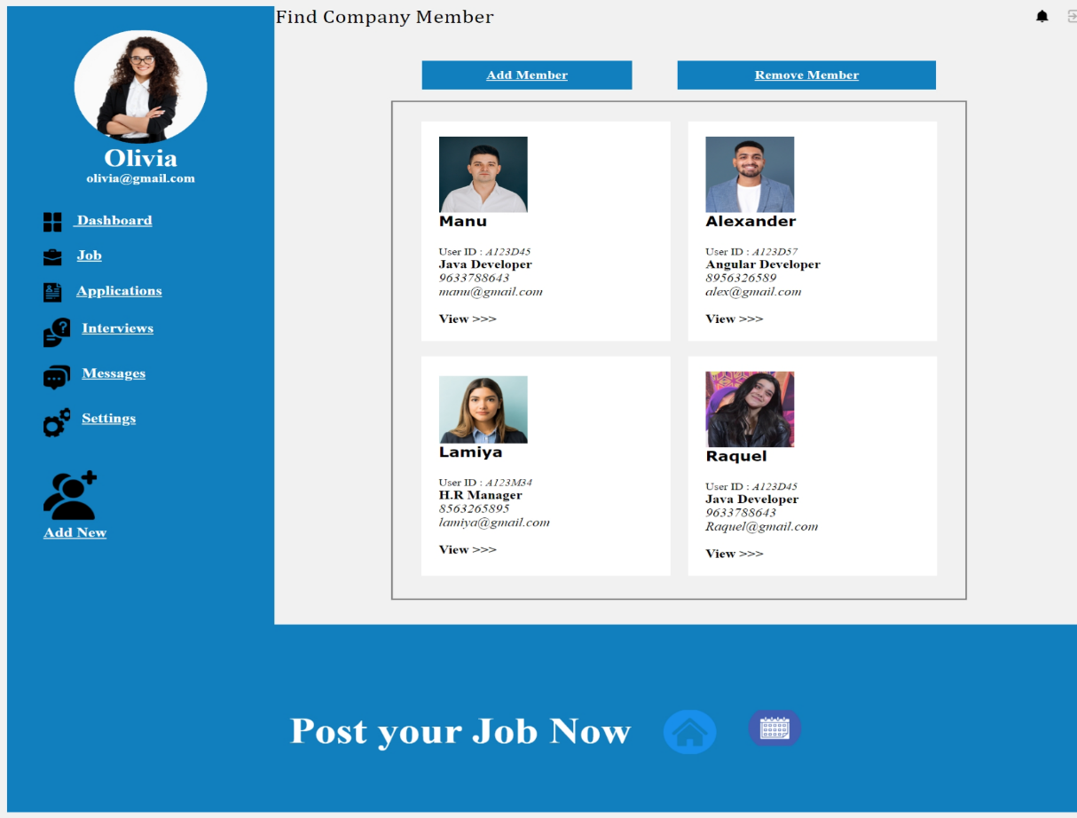
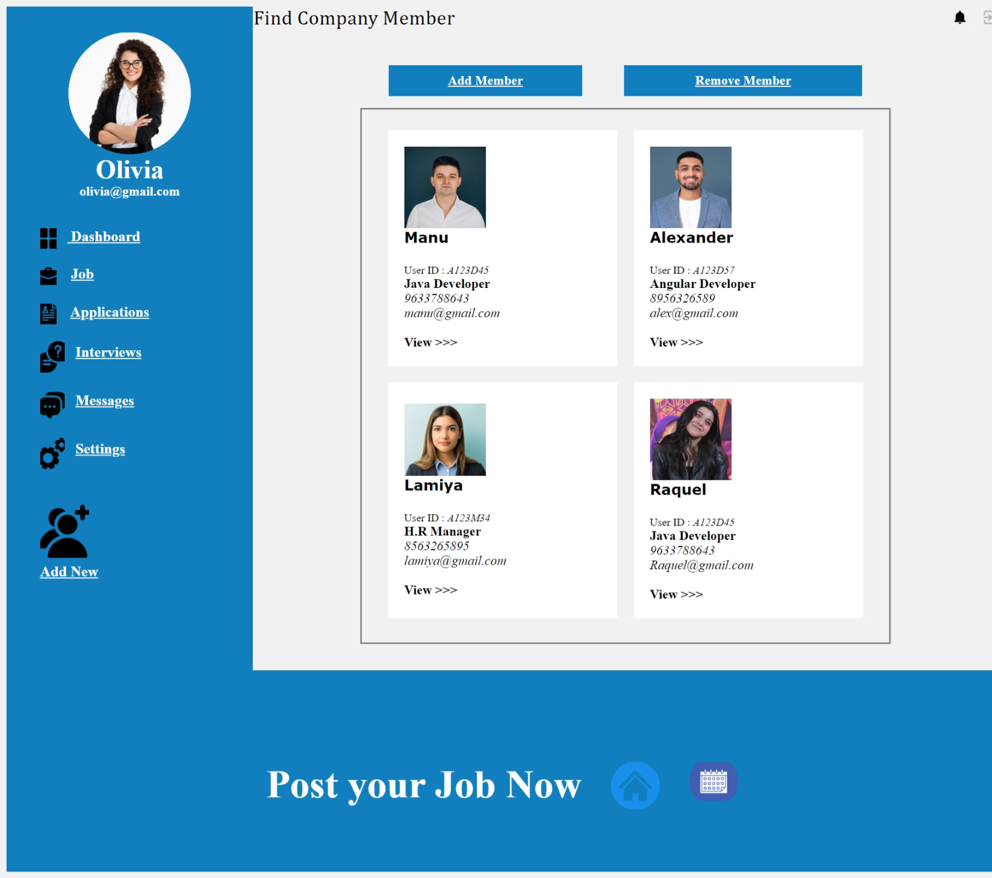


Expected output:-


During this workshop, we will be constructing a FindCompanyMembers page for JobProviders. On this page, using the <table> tag to create a structured layout for a web page , dividing it into rows and columns where content like text and images can be placed. The attributes(width,cellpadding,cellspacing,bgcolor,colspan,rowspan) and tags (<table>,<tr>,<td>,<th>)within the table are used to control the appearance and arrangement of this page. , let's incorporate a content section as a row in our table , further enhancing the structure and completeness of our tables.

